The university of Azad Jammu and Kashmir Muzaffarabad

Student Name: Qurat Ul Ain Fatima
Roll No: 2024-SE-05
Course Title: Database Systems
Course Code: CS-2204
Lab Instructor: Awais Rathore
Department: Software Engineering
Lab#06
Introduction:
SQL filtering is used to retrieve specific records from a database table according to defined conditions. The WHERE clause is one of the fundamental SQL clauses used for filtering rows.
This experiment focuses on the use of the WHERE clause with comparison and logical operators. An Employee database is used to demonstrate how specific employee records can be retrieved based on salary, city, gender, department, and job title.
The experiment provides practical understanding of how multiple conditions can be combined to produce meaningful query results.

Database Creation:
The following SQL statement creates the database and selects it for use:
CREATE DATABASE IF NOT EXISTS filters_lab;

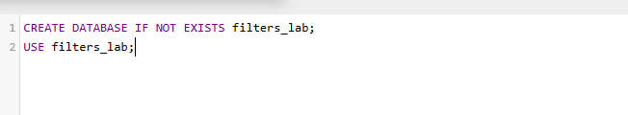
Table Creation:
Employee table:

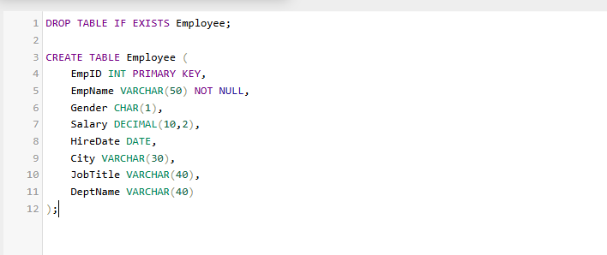
Data insertion: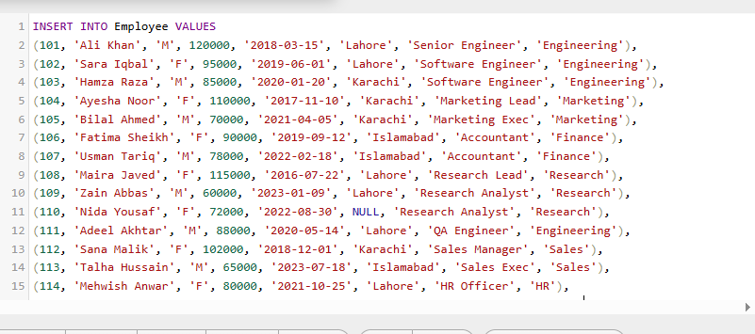

The WHERE Clause
The WHERE clause is used to specify conditions for filtering records.
Comparison Operators
Comparison operators are used to compare values within SQL conditions.
Operator | Meaning
= | Equal to
!= or <> | Not equal to
< | Less than
> | Greater than
<= | Less than or equal to
>= | Greater than or equal to

Logical Operators
Logical operators are used to combine or reverse conditions.
11.1 AND
The AND operator requires all specified conditions to be true.
OR
The OR operator returns records when at least one of the specified conditions is true.
NOT
The NOT operator reverses a specified condition.

Part A
Comparison and logical operators
Task A1 — Salary Greater Than 90,000
Problem:
List the EmpID, EmpName, and Salary of all employees who earn more than 90,000.

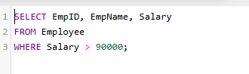
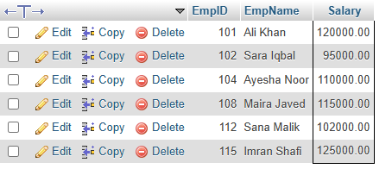
Task A2 — Salary Less Than or Equal to 75,000
Problem:
Display the EmpName and Salary of all employees whose salary is less than or equal to 75,000.
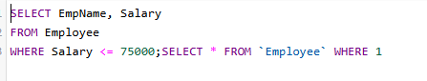
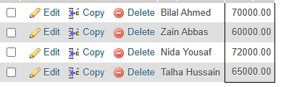
Task A3 — Lahore Employees Earning More Than 90,000
Problem:
Find employees who work in Lahore and earn more than 90,0
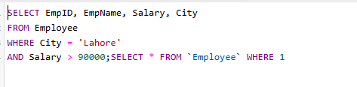
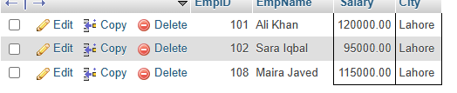
Task A4 — Employees in Karachi or Islamabad
Problem:
List employees who work in either Karachi or Islamabad.
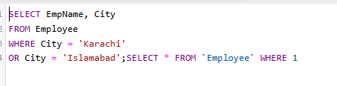
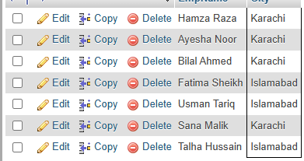
Task A5 — Female Employees Outside Engineering
Problem:
Find female employees who are not working in the Engineering department.
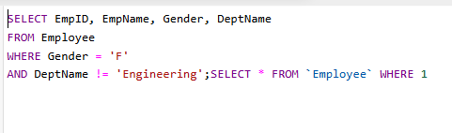
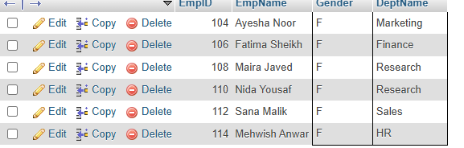
Task A6 — Male Employees with Salary Between 70,000 and 90,000
show male employees whose salary is between 70,000 and 90,000. Use comparison operators and AND; do not use BETWEEN.
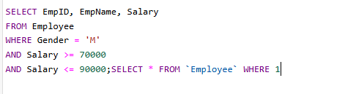
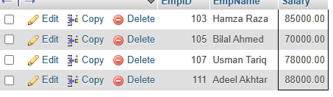
Task A7 — Software Engineers or Employees Earning More Than 100,000
Problem:
List employees who are Software Engineers or whose salary is greater than 100,000.
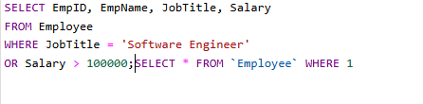
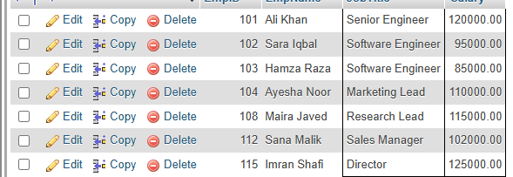
Task A8 — Employees Outside Marketing and Sales
Problem:
Find employees who are neither in the Marketing department nor in the Sales department.
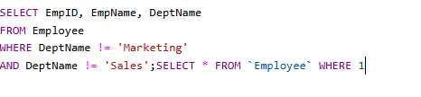
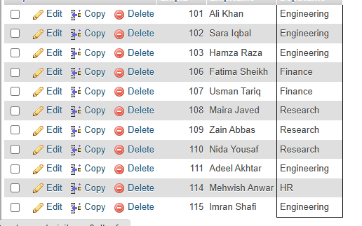

Conclusion
This experiment provided practical experience with SQL filtering using the WHERE clause. Comparison operators were used to compare numerical and text values, while AND, OR, and NOT were used to combine different conditions. The practical tasks demonstrated how SQL filtering can be applied to retrieve specific employee records from a relational database.

